1. Create a

dashboard that shows sales trends over time, by region, and by product category.

Use different visualizations to highlight key metrics, such as sales growth

rates, top-selling products, and regional sales comparisons.

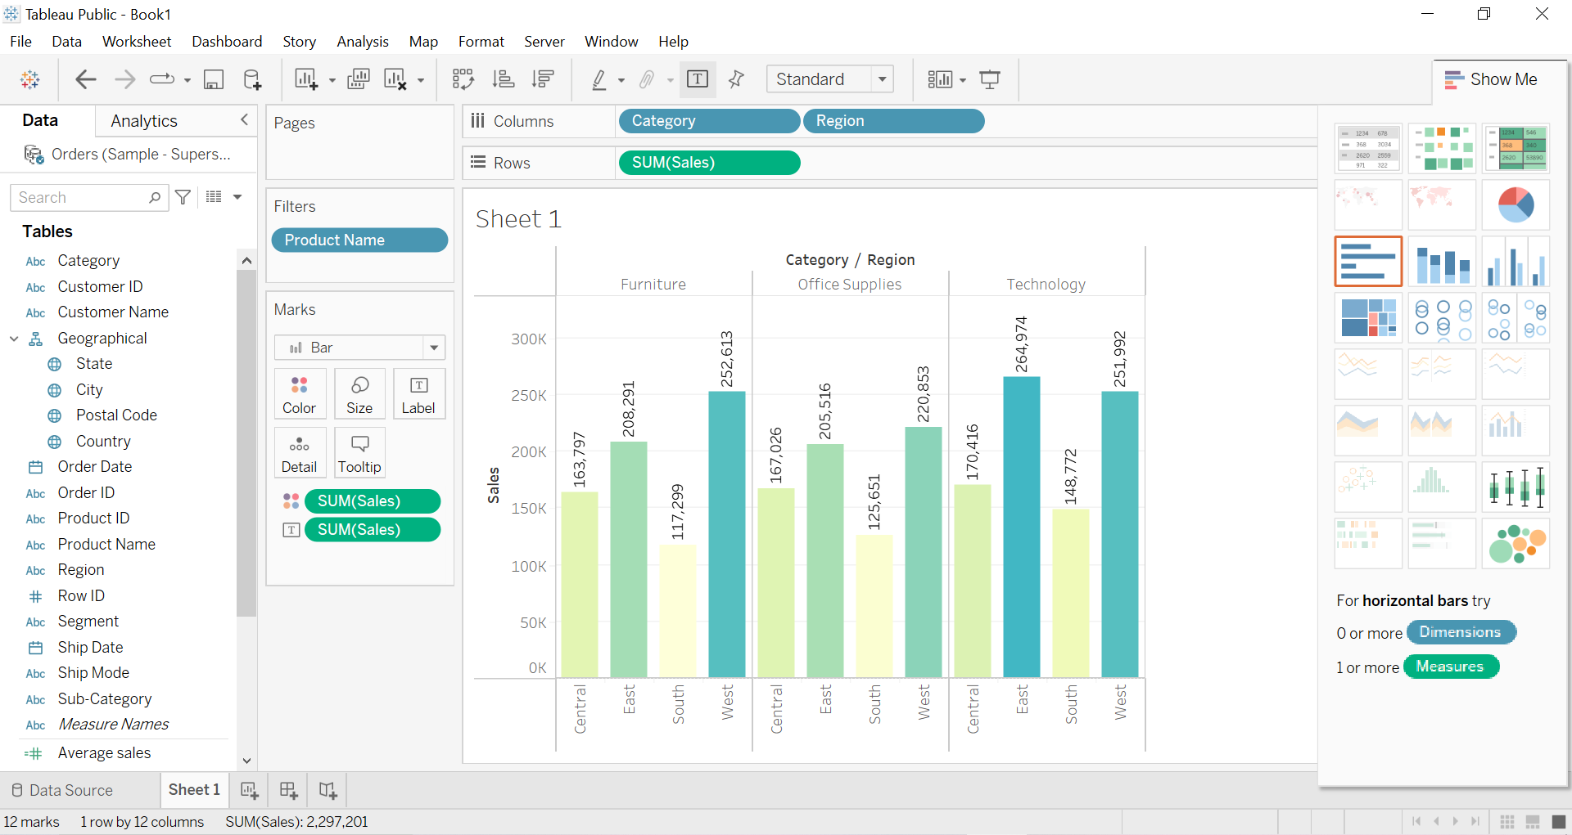

2.Analyze

customer data to identify key segments and create visualizations that show

their characteristics, behaviors, and purchasing patterns. Use clustering

techniques to group customers into segments, and then create visualizations

that show how they differ in terms of demographics, purchasing frequency, and

other factors.

